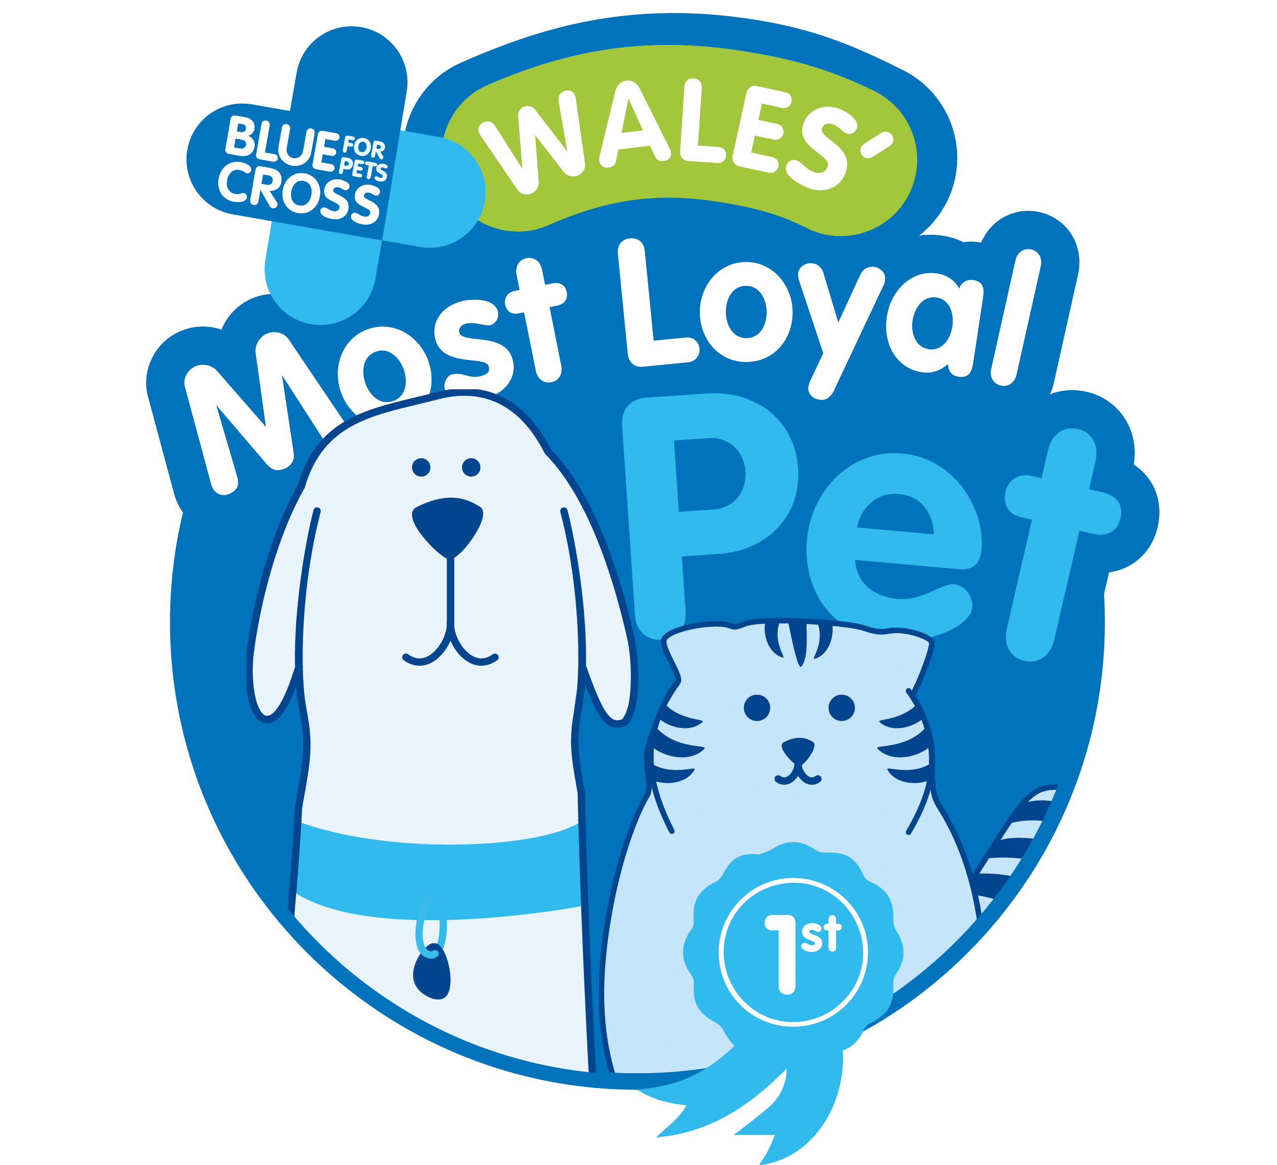

Blue Cross Competition

Covid-19: Wales’ most loyal pet
Entry Form
Name:
Address:
Email address:
Phone Number:
Name, type and breed of pet:

If the pet is not yours, do you have the permission of the owner to enter the competition? Yes No
I certify that I am over 16 years of age? Yes No
(If you are under 16, you will need the permission from a parent or guardian to take part)
Please outline, in no more than 500 words on why your pet should be crowned Wales’ most loyal pet. Please also feel free to submit a photograph or video clip of your pet with your submission if you wish.

Terms & Conditions
Rules of entry for the competition and more details of how to enter are can be found at www.bluecross.org.uk/news/wales-most-loyal-pet-2020
Closing Date for entries will be the 11 January. No further entries to the competition will be permitted after this date.
By entering the competition, the entrants agree that Blue Cross can use their submission and photographs submitted in press and marketing activity, including in media coverage surrounding the competition.
Blue Cross wish to use your personal information for use in the competition and this may, on occasion, include information about your health including mental health. This is categorised as Special Categories of Personal Data in Data Protection law and requires extra protection. Please confirm that you are absolutely certain that you are happy for us to use and refer to the information you provide us, including physical and or mental health, in promoting the competition by ticking this box.

